SBC-IMX8MM

Quick Operation Guide

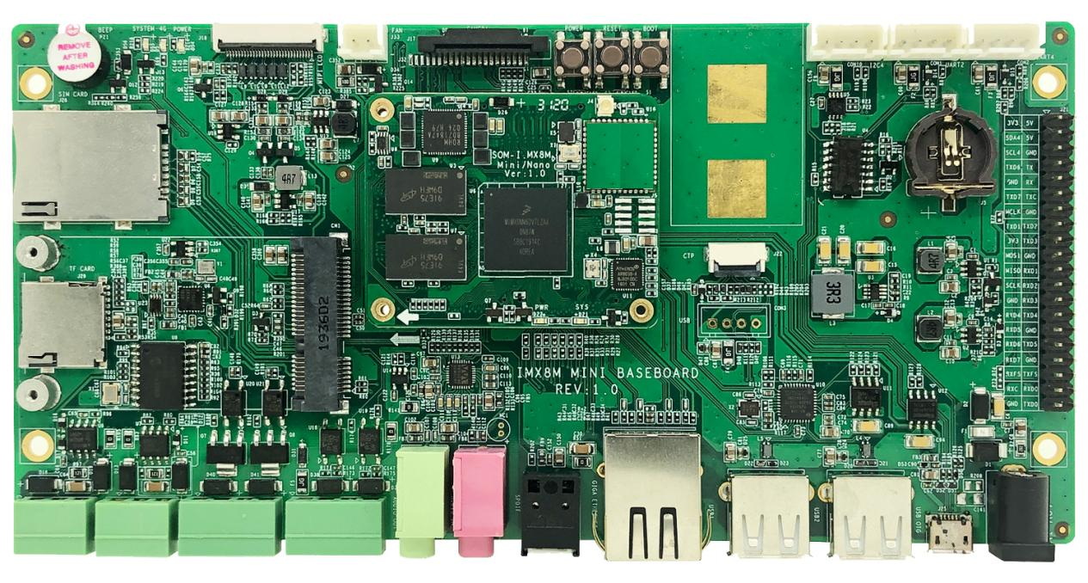

**EMTOP Technology Co.,Ltd.**

www.emtop-tech.com

Table of Contents

[Product Overview 1](#_Toc1266)

[1. Packing List 1](#_Toc6719)

[2. Factory Default Conditions 1](#_Toc1387)

[Preparations 2](#_Toc27488)

[1. Setting Up HyperTerminal 2](#_Toc2309)

[2. Hardware Connects 6](#_Toc12213)

[Linux Operating System 7](#_Toc12857)

[1. Create System TF Card 7](#_Toc9891)

[2. Update of TF Card System Image 8](#_Toc30329)

[3. Update eMMC 9](#_Toc23781)

[Technical Support and Warranty 10](#_Toc20548)

# Product Overview

## Packing List

* SBC-8MX8MM×1
* Serial Cable (USB To TTL)×1
* 12V Power Adapter×1
* Cross-Over Network Cable×1
* MIPI To HDMI\_LVDS Adapter Board X1

## Factory Default Conditions

* A Linux system is already programmed in the on-board EMMC and supports HDMI by default; If another display mode is required, please refer to the Display Mode Configurations in user manual.
* SBC-IMX8MM has no CR1220 battery installed on board; Please purchase it if necessary.
* SBC-IMX8MM Single Board Computer preferably boots from EMMC by default, if you want to boot from TF Card, you need to press Boot Button before Power up
* Wiki

# Preparations

## Setting Up HyperTerminal

1. Click **Start** > **Programs** > **Accessories** > **Communications** > **HyperTerminal** on your PC’s desktop;

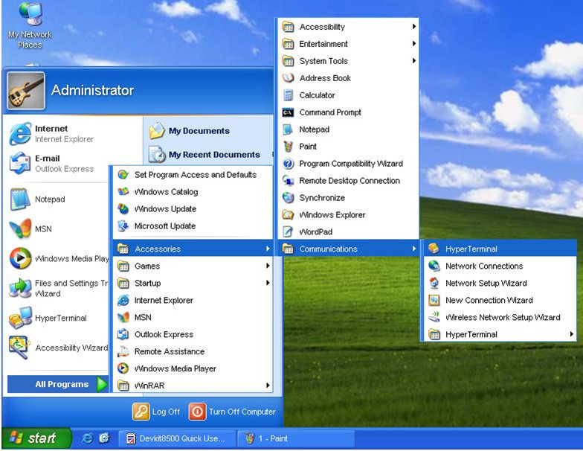

1. Start HyperTerminal
2. Enter a name in the **Name** field and select an icon below, and then click **OK**;

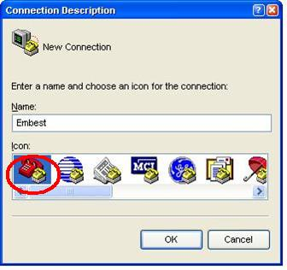

1. Enter a Name
2. Select the port to be used and click **OK**;

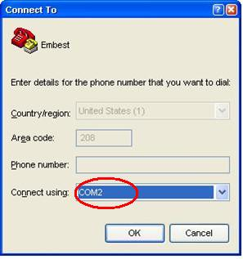

1. Select Port
2. Please configure the port you selected as shown in the following window, and then click **OK**;

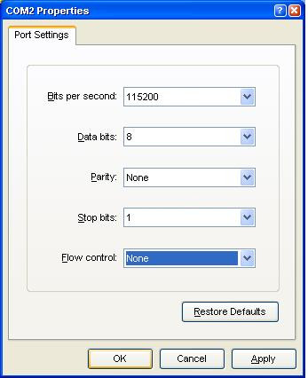

1. Configure Port
2. HyperTerminal has been set up successfully.

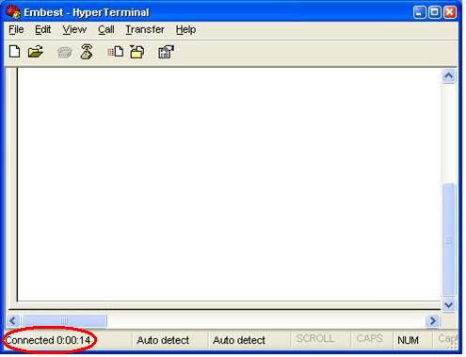

1. HyperTerminal Window

## Hardware Connects

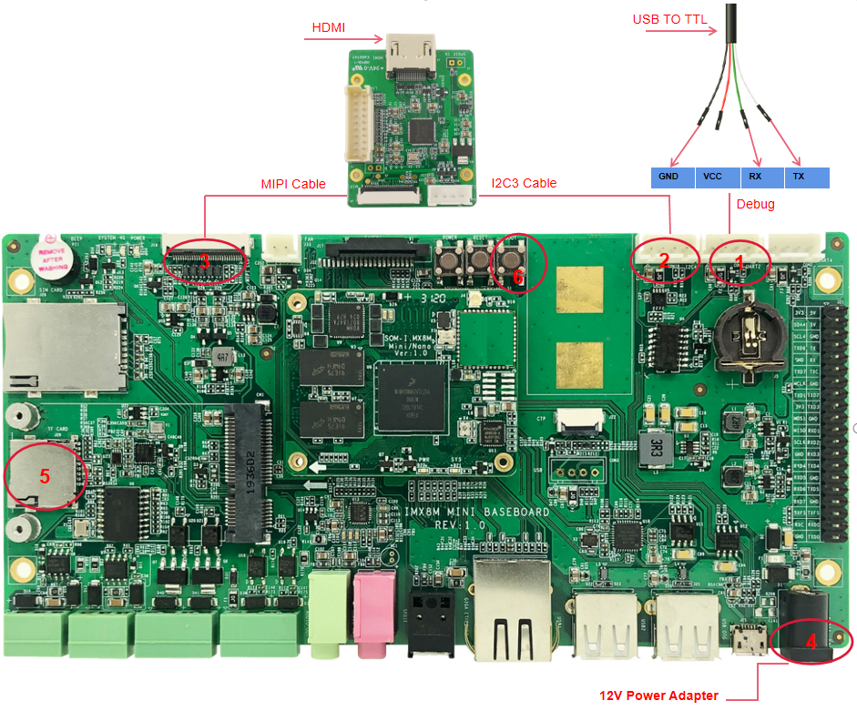

1. Hardware Connections
2. Connection Details

| **No.** | **Descriptions** | **No.** | **Descriptions** |
| --- | --- | --- | --- |
| **1** | Connect Serial Cable | **4** | Connect a Power Adapter |
| **2-3** | Connect HDMI Adapter Board | **5-6** | If you want to boot from TF card,  Need Press boot button before Power Up |

# C:/Users/Joe Zou/AppData/Local/Temp/picturecompress_20220429111117/output_1.jpgoutput_1

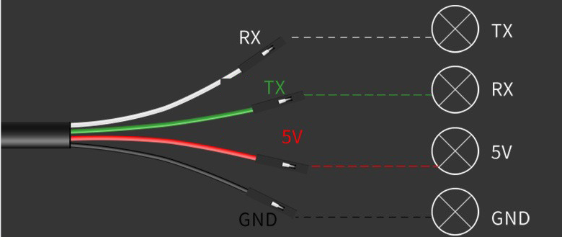

# Linux Operating System

## Create System TF Card

Download HP USB Disk Storage Format Tool 2.0.6 , and use it to format TF card; the figure shown below is the tool’s interface;

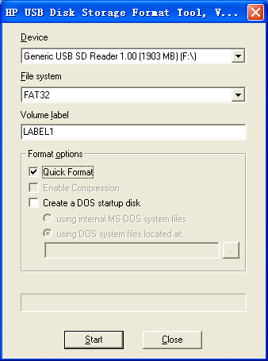

1. Format TF Card

Select **FAT32** in the **File system** drop-down menu, and then click **Start** to format TF card.

Note:

* It is not recommended to use other versions of HP USB Disk Storage Format Tool.
* HP USB Disk Storage Format Tool will erase the partitions of TF card.

IMX8MMINI DEMO can boot up from both TF card and eMMC, this section briefly introduce the process of system update on TF card and eMMC.

## Update of TF Card System Image

* 1. **Make A Bootable TF Card**

1. Get the system image from **Image** directory, named as **imx-image-xxx.img.xz**, unxz it and create a raw image **imx-image-xxx.img**.
2. If you work under Windows system, please run **Tools/win32diskimager** to write the **imx-image-xxx.img** into TF Card. If you work under Linux system, please use **dd** command to write it into TF Card.

|  |  |
| --- | --- |
| Image Name | Display Supported |
| imx-image-full-imx8mmddr4evk-xxx.img | MIPI-DSI |
| imx-image-full-imx8mmddr4evk-xxx-hdmi.img | HDMI |

**Note:**

* The difference between **imx-image-full-imx8mmddr4evk-xxx.img** and **imx-image-full-imx8mmddr4evk-xxx-hdmi.img** is that the **fdt\_file** in **uEnv.txt** chooses a different dtb.

1. **Update U-Boot**

If you’ve made some changes to the u-boot source code, and want to update it into TFCard, please run the below command:

* **dd if=<YOUR\_PATH>/flash.bin of=/dev/sdx bs=1K seek=33 conv=notrunc**

**Note:**

* **/dev/sdx** is the TFCard device node recognized under Ubuntu system.

1. **Update Kernel**

If you have modified the kernel source code, please update the dtb and Image under Partition 1 [FAT32] of the TF Card. That partition can be recognized by Windows or Linux.

1. **Update Rootfs**

Because EXT4 isn’t accessible Under Windows, please mount the Partiton 2 of TF Card under Ubuntu, change the target file and umount the Card.

**Note:**

* Press down the button "**BOOT**" before power up, don't release it. Wait until booting message shows on the terminal [3 seconds at most], release the button.

## Update eMMC

* + Make a bootable TFCard and boot up the system;
  + Choose the target image [under directory **Image/**] and copy it into the USB disk. If it is **.xz** file, please unxz it to generate **.img** file.
  + Install the USB disk on the ARM board, it will be automatically mounted under directory **/run/media/**, for example, the USB disk is recognized as **sda1**;
  + Run command to start writing eMMC:
* **root@imx8mmddr4evk:~# umount /dev/mmcblk2\***
* **root@imx8mmddr4evk:~# dd if=/run/media/sda1/imx-image-full-imx8mmddr4evk-xxx.img of=/dev/mmcblk2**

After it's done, power off the board, remove the TFCard, then reboot the board, it should boot from eMMC and enter into Linux prompt.

Technical Support and Warranty

说明: snap017Technical Support

Emtop Technology provides its product with one-year free technical support including:

* Providing software and hardware resources related to the embedded products of Emtop Technology;
* Helping customers properly compile and run the source code provided by Emtop Technology;
* Providing technical support service if the embedded hardware products do not function properly under the circumstances that customers operate according to the instructions in the documents provided by Emtop Technology;
* Helping customers troubleshoot the products.

说明: snap018The following conditions will not be covered by our technical support service. We will take appropriate measures accordingly:

* Customers encounter issues related to software or hardware during their development process;
* Customers encounter issues caused by any unauthorized alter to the embedded operating system;
* Customers encounter issues related to their own applications;
* Customers encounter issues caused by any unauthorized alter to the source code provided by Emtop Technology;

Warranty Conditions

1. 12-month free warranty on the PCB under normal conditions of use since the sales of the product;

The following conditions are not covered by free services; Emtop Technology will charge accordingly:

Customers fail to provide valid purchase vouchers or the product identification tag is damaged, unreadable, altered or inconsistent with the products.

Products are damaged caused by operations inconsistent with the user manual;

Products are damaged in appearance or function caused by natural disasters (flood, fire, earthquake, lightning strike or typhoon) or natural aging of components or other force majeure;

Products are damaged in appearance or function caused by power failure, external forces, water, animals or foreign materials;

Products malfunction caused by disassembly or alter of components by customers or, products disassembled or repaired by persons or organizations unauthorized by Emtop Technology, or altered in factory specifications, or configured or expanded with the components that are not provided or recognized by Emtop Technology and the resulted damage in appearance or function;

Product failures caused by the software or system installed by customers or inappropriate settings of software or computer viruses;

Products purchased from unauthorized sales;

Warranty (including verbal and written) that is not made by Emtop Technology and not included in the scope of our warranty should be fulfilled by the party who committed. Emtop Technology has no any responsibility;

Within the period of warranty, the freight for sending products from customers to Emtop Technology should be paid by customers; the freight from emtop to customers should be paid by us. The freight in any direction occurs after warranty period should be paid by customers.

Please contact technical support if there is any repair request.

Note:

* Emtop Technology will not take any responsibility on the products sent back without the permission of the company.

Contact Information

**Technical Support**

Tel: +86-0755-23742193

Email: support@emtop-tech.com

**Sales Information**

Email: sales@emtop-tech.com

**Company Information**

Website: www.emtop-tech.com